NAME | KABA PETER NEBA
TASK | Zero-Trust Access Control System for University Campus Description
TRACK | Networking and Cybersecurity

- Introduction
I was asked to design a zero-trust security architecture for a university network. In this design, no user or device is trusted automatically. I used Cisco Packet Tracer to set up authentication, network segmentation, role-based access control, logging, and containment of a compromised device.

- Task Detail
Design and implement a zero-trust security architecture for a university network in which no user is automatically trusted. The system should authenticate users, verify device security status. Enforce role-based access control, segment network resources, and continuously record access decisions. Demonstrate how the platform prevents unauthorized access and limits lateral movement when a test account or device is compromised.

- Main Objectives
- Authenticate every user with username and password.
- Isolate bad or compromised devices.
- Give access based on role (Student, Lecturer, Admin).
- Divide network into VLANs.
- Record all logins.
- Stop an attacker from moving to other parts of the network.

- Network Design
  - Devices Used
I used 2 switches:
- Core 3560: The main router and DHCP server.
- Access 2960: The gatekeeper that checks users.
And 4 PCs and 2 Servers.

  - Topology
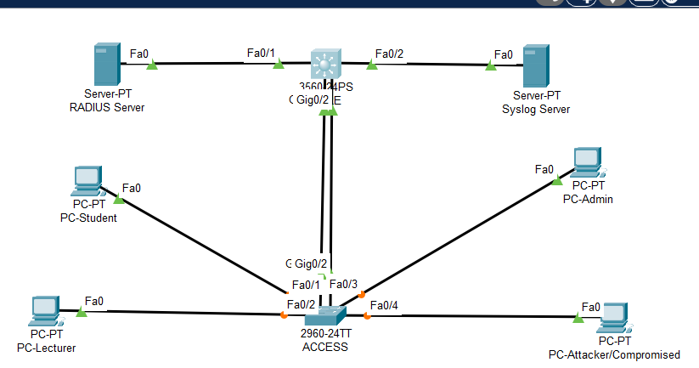
  - Connections
Using a copper straight-through cable.
- PC-Student(F0) > Access 2960 (F0/1)
- PC-Lecturer(F0) > Access 2960 (F0/2)
- PC-Admin(F0) > Access 2960 (F0/3)
- PC-Attacker/Compromised(F0) > Access 2960 (F0/4)
- Access 2960 (G0/1) > CORE 3560 G0/1
- Access 2960 G0/2 > CORE 3560 G0/2 (for etherchannel)
- CORE 3560 F0/1 > RADIUS Server F0
- CORE 3560 F0/2 > Syslog Server F0
  - IP Address Plan
VLAN | Role | Subnet | Gateway | Purpose
10 | Servers | 192.168.10.0/24 | 192.168.10.1 | RADIUS (.5) and Syslog (.6)
20 | Students | 192.168.20.0/24 | 192.168.20.1 | Student role
30 | Lecturers | 192.168.30.0/24 | 192.168.30.1 | Lecturer role
99 | Admin | 192.168.99.0/24 | 192.168.99.1 | Admin role
100 | Quarantine | 192.168.100.0/24 | 192.168.100.1 | Isolates compromised devices

- HOW THE TASK WAS DONE
Step 1:
- Open Cisco Packet Tracer and start a new file
- Add a 3560 switch(CORE), one 2960 switch (ACCESS), 2 servers and 4 PCs.
- Connect them with copper straight-through cables as shown in section 4.3.
- Rename the devices (CORE, ACCESS, PC-Students, PC-Lecturers, PC-Admin, PC-Attacker/Compromised, RADIUS(Server1)and Syslog(Server2)).
Step 2: Configure the CORE(Switch 3560)
I created all the VLANs, gave each VLAN interface (SVI) an IP address, turned on ip routing, and created a DHCP pool for each role. I set up an EtherChannel (Port-Channel 1) between the Core and Access switches as a trunk carrying all VLANs.
I used extended ACLs for role-based access control:
- RBAC-STUDENT: blocks the Student VLAN (20) from reaching the Admin (99) and Server (10) networks.
- BLOCK-QUARANTINE: blocks the Quarantine VLAN (100) from all internal networks, except Syslog for remediation.
I applied both ACLs inbound on the VLAN interfaces. I also enabled AAA, pointed the switch to the RADIUS server (192.168.10.5), and set up logging to the Syslog server.
On CORE, I opened “CLI” and enter the following command:
enable
conf t
hostname CORE
vlan 10
name SERVERS
vlan 20
name STUDENTS
vlan 30
name LECTURERS
vlan 99
name ADMIN
vlan 100
name QUARANTINE
exit

interface vlan 10
ip address 192.168.10.1 255.255.255.0
no shutdown
interface vlan 20
ip address 192.168.20.1 255.255.255.0
no shutdown
interface vlan 30
ip address 192.168.30.1 255.255.255.0
no shutdown
interface vlan 99
ip address 192.168.99.1 255.255.255.0
no shutdown
interface vlan 100
ip address 192.168.100.1 255.255.255.0
no shutdown

ip routing

interface range g0/1-2
channel-group 1 mode active
interface port-channel 1
switchport mode trunk
switchport trunk allowed vlan 10,20,30,99,100

interface f0/1
switchport access vlan 10
interface f0/2
switchport access vlan 10

ip dhcp pool STUDENT
network 192.168.20.0 255.255.255.0
default-router 192.168.20.1
ip dhcp pool LECTURER
network 192.168.30.0 255.255.255.0
default-router 192.168.30.1
ip dhcp pool ADMIN
network 192.168.99.0 255.255.255.0
default-router 192.168.99.1
ip dhcp pool QUARANTINE
network 192.168.100.0 255.255.255.0
default-router 192.168.100.1

ip access-list extended RBAC-STUDENT
deny ip 192.168.20.0 0.0.0.255 192.168.99.0 0.0.0.255
deny ip 192.168.20.0 0.0.0.255 192.168.10.0 0.0.0.255
permit ip any any

ip access-list extended BLOCK-QUARANTINE
deny ip 192.168.100.0 0.0.0.255 192.168.0.0 0.0.255.255
permit ip 192.168.100.0 0.0.0.255 host 192.168.10.6

interface vlan 20
ip access-group RBAC-STUDENT in
interface vlan 100
ip access-group BLOCK-QUARANTINE in

aaa new-model
radius-server host 192.168.10.5 key Secret123
aaa authentication dot1x default group radius
logging host 192.168.10.6
end
wr

Step 4: Configuring the ACCESSS(Switch 2960)

This switch enforces the security policy. I set up the trunk to the Core and assigned the access ports: F0/1 to VLAN 20, F0/2 to VLAN 30, F0/3 to VLAN 99, and F0/4 to VLAN 100. I then enabled aaa new-model, added the RADIUS server, and ran dot1x system-auth-control. On each access port I used authentication port-control auto and dot1x pae authenticator. This keeps each port blocked until the user logs in successfully.
On ACCESS, enter the following commands:
enable
conf t
hostname ACCESS
vlan 10
vlan 20
vlan 30
vlan 99
vlan 100
exit
interface range g0/1-2
channel-group 1 mode active
interface port-channel 1
switchport mode trunk
switchport trunk allowed vlan 10,20,30,99,100

interface f0/1
switchport mode access
switchport access vlan 20
authentication port-control auto
dot1x pae authenticator
spanning-tree portfast
interface f0/2
switchport mode access
switchport access vlan 30
authentication port-control auto
dot1x pae authenticator
spanning-tree portfast
interface f0/3
switchport mode access
switchport access vlan 99
authentication port-control auto
dot1x pae authenticator
spanning-tree portfast
interface f0/4
switchport mode access
switchport access vlan 100
authentication port-control auto
dot1x pae authenticator
spanning-tree portfast

interface vlan 10
ip address 192.168.10.2 255.255.255.0
no shutdown

aaa new-model
radius-server host 192.168.10.5 key Secret123
aaa authentication dot1x default group radius
dot1x system-auth-control
logging host 192.168.10.6
end
wr

Step 5: Configuring Servers
I gave both servers static IP addresses with the gateway 192.168.10.1. On the RADIUS server, I turned on the AAA service and added two clients: CORE (192.168.10.1) and ACCESS (192.168.10.2). I then created four users:
Username | Password | Role
student01 | Student@123 | Student
lecturer01 | Lecturer@123 | Lecturer
admin01 | Admin@123 | Admin
compromised | badpass | Attacker (test account)

On the Syslog server, I turned on the Syslog and HTTP services.
- End Devices(PCs)
On each PC, I first set the IP configuration to DHCP. The PC showed 0.0.0.0 because its port was still blocked. I then turned on 802.1X with EAP type MD5, entered the user's credentials, and reconnected. After successful login, I renewed the DHCP address.
- PC-Student logged in as student01 and received 192.168.20.x.
- PC-Lecturer logged in as lecturer01 and received 192.168.30.x.
- PC-Admin logged in as admin01 and received 192.168.99.x.
- PC-Attacker used the compromised account and was placed in VLAN 100 with 192.168.100.x

7. My Results / Proof
1. Authentication: My PC shows 802.1X Success. Command show dot1x all on ACCESS shows AUTHENTICATED.
2. Quarantine: PC-Attacker with compromised gets IP 192.168.100.x and cannot leave that VLAN.
3. Role-Based Access: From Student PC I pinged Admin PC – it failed (Request timed out). This proves my ACL works.
4. Logging: On Syslog server I saw logs for success and failure.
5. Limit Lateral Movement: From Attacker PC I tried to ping RADIUS (192.168.10.5) and Student gateway (192.168.20.1) – all failed. The attacker is trapped. This is exactly what zero-trust wants.

8. LIMITATIONS
- The shared secret and user passwords are for lab use only. A real network should use strong secrets and certificate-based authentication (EAP-TLS) instead of MD5.
- Packet Tracer has limited 802.1X support, so the quarantine may depend on the static assignment of port F0/4 to VLAN 100.
- ACLs and 802.1X provide segmentation and authentication, but they do not continuously re-check devices after login. A full zero-trust system would add that.

9. Conclusion
I built a working zero-trust network. No one gets access without login, roles are enforced, bad devices are isolated, and all events are logged.

